KENDRIYA VIDYALAYA MORADABAD
ACHIEVEMENTS SESSION 2021-2022

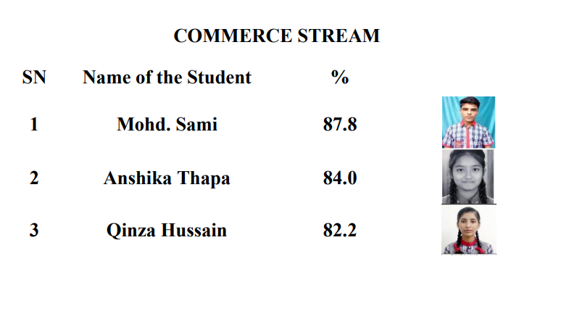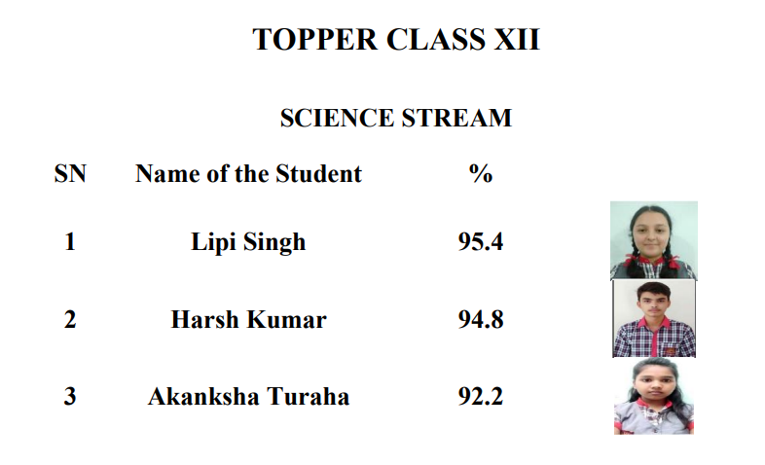
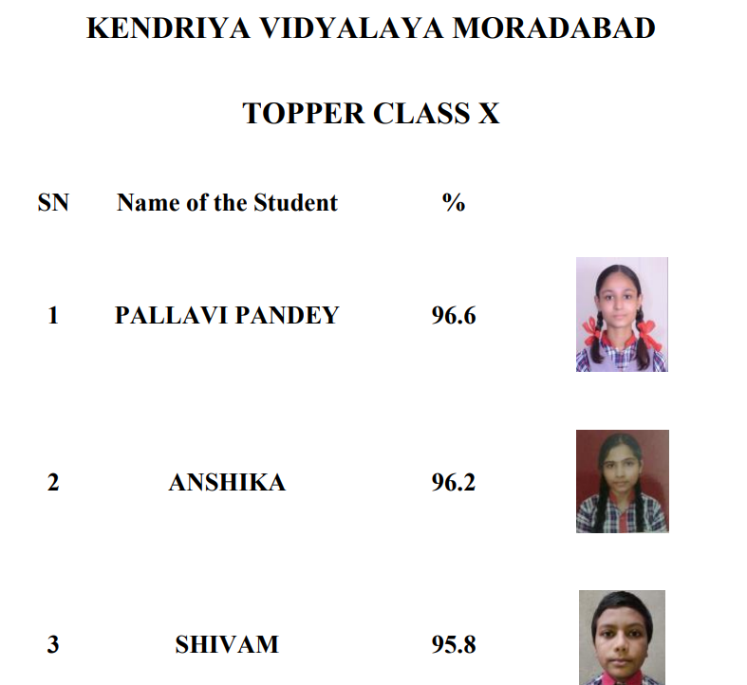

ALUMNI
- Pankaj Singh -selected in JEE MAINS
- Paridhi Singh -selected in NEET

VARIOUS ACTIVITIES
Various activities were organized throughout the year under
- Azadi Ka Amrut Mahotsava which included
Poster Making
Essay Writing
Rangoli Making
Elocution
Debate
Drawing and Painting
Slogan Writing etc.
CLUSTER LEVEL AKAM GROUP SONG COMPETITION | KV MORADABAD | I POSITION
CLUSTER LEVEL SOLO SONG GIRLS(JUNIOR) | KV MORADABAD | II POSITION
CLUSTER LEVEL SOLO SONG GIRLS(SENIOR) | KV MORADABAD | II POSITION
CLUSTER LEVEL SOLO SONG BOYS(SENIOR) | KV MORADABAD | II POSITION
REGIONAL LEVEL AKAM GROUP SONG COMPETITION | KV MORADABAD | II POSITION

- KALA UTSAV which included
Vocal Music Competitions
Master Kunwarjeet Singh bagged first position in
Regional Level Kala Utsav
Category:Vocal Music Classical (Male)

Instrumental Music Competitions
Master Sangam Nagpal secured third position in Regional Level Kala Utsav
Category: Classical Instrumental(Male)

Painting Competitions
Toy Making Competitions
- SHIKSHAK PARV
KV MORADABAD hosted the District Level Ten Day Seminar for All CBSE Affiliated Schools of Moradabad.
The seminars were attended by Regional Officer CBSE Shri Ranbir Singh,
City Coordinator and Principles of all CBSE affiliated Schools.
- Miss Bhawana, Shooting Champion KV Moradabad, was honoured by Ms. Babita Phogat, Commonwealth Gold Medalist 2014

- The schools green initiative was recognized by Centre for Science and Environment

ACTION PLAN FOR BOARD CLASSES
- Identification of the slow learners and their weak areas, preparation of remedial study material accordingly.
- Identification of the slow learners and their weak areas, preparation of remedial study material accordingly.
- Planning of practice sessions of ‘writing-answers’ and slip tests.
- Preparation of study material containing HOTS for bright learners.
- Separate group discussions, quiz, debate sessions as required for analysis based learning.
- Relevant and sufficient home work focusing on writing skills.
- For subject Social Science map based exercises.
- Planning of practice sessions of ‘writing-answers’ and slip tests.
- Preparation of study material containing HOTS for bright learners.
- Separate group discussions, quiz, debate sessions as required for analysis based learning.
- Relevant and sufficient home work focusing on writing skills.
- For subject Social Science map based exercises.
- Slip tests during study camp.
- Extra classes for daily practice of late bloomers during morning assembly.
- Teach-Test-Reteach cycle to be followed during extra classes and study camp.
- Latest CBSE sample paper practice for all.
- Practise of three Board Exam papers with late bloomers

- Slip tests during study camp.
- Extra classes for daily practice of late bloomers during morning assembly.
- Teach-Test-Reteach cycle to be followed during extra classes and study camp.
- Latest CBSE sample paper practice for all.
- Practise of three Board Exam papers with late bloomers.

